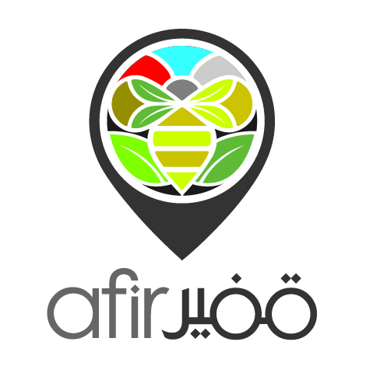  Beekeeping Apprenticeship Program  Feb.-Oct. 2019 | Saidoun - Jezzine (South Lebanon)  Round 2 |  |  |  |  |  |  |  | 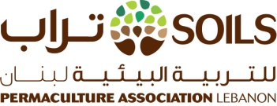
REGISTRATION FORM
Please fill the form below and send it by email to contact.soilslebanon@gmail.com by February 9, 2019 at the latest
*All fields are required - Write N/A where the information is not applicable
PERSONAL INFORMATION
1. First name: |  |  |  |  |  |  | 3. Date of birth (DD/MM/YYYY)
2. Last name: |  |  |  |  |  |  | 4. Gender(Male/Female)
CONTACT DETAILS |  |  |  |  |  |  | ADDRESS
5.Mobile |  |  |  |  |  |  | 8. Caza
6. Landline |  |  |  |  |  |  | 9. City or Village
7. Email |  |  |  |  |  |  | 10. Street
BEEKEEPING EXPERIENCE
11. Have you completed a Beekeeping Introductory Workshop?(YES/NO)
If yes, please state with whom and program covered.

FOOD/SAFETY INFORMATION
12. Do you have specific diet needs or restrictions?(YES/NO)
If YES, please specify (vegan, vegetarian, gluten-free, etc.)
13. Do you suffer from any allergies/chronic conditions?(YES/NO)
If YES, please list your medication(s) and dosage
IN CASE OF EMERGENCY, WHOM SHOULD WE CONTACT?
14. Emergency contact name |  |  |  |  |  | 15. Emergency contact tel.
PARTICIPATION FEES
Fees include tuition costs, training materials, and all meals/snacks
Regular participants |  | Session 1 (mandatory): $100  Sessions 2-7: $50 per session  Session 8: FREE - IF participants attend all 7 previous sessions  Total: $400

Do you have any comments, questions or anything else you'd like to share with us?

For further questions and details, please email us: contact.soilslebanon@gmail.com or call +961-71-617988

